# The State of the Art: Multiple Stressors

The combined effects of mixtures of toxins and multiple stressors has long been a source of fascination for the field of academic ecotoxicology (Bliss, 1939). The environment today is awash with anthropogenic stressors, including potentially harmful chemicals (over 20,000 registered at last count (ECHA, 2018)), habitat loss, climate change, and competition with invasive species.

Despite this level of interest, advances in knowledge have not translated to corresponding legislative changes, with existing mixture toxicity regulations limited and distinctly human-focused (European Commission, 2012). Consensus on experimental and statistical design has also been lacking, with studies applying a variety of potentially inappropriate models (Piggott, Townsend and Matthaei, 2015; Schäfer and Piggott, 2018), and a longstanding criticism from within the field of the difficulty of integrating ecotoxicological results into larger-scale understanding of how ecosystems respond to stress (Chapman, 2002; Gessner and Tlili, 2016).

A particular complication to more advanced ecosystem-level understanding of stressors is found at the highly consequential microbial layer. A great deal of research has been conducted into the bioremediation potential of individual bacterial isolates (Mary Kensa, 2011), the size, diversity and abundance of microbial life has limited both the commissioning and consistency of research on microbial ecotoxicology (Ghiglione, Martin-Laurent and Pesce, 2016) compared to more traditional clades of study, such as aquatic invertebrates and vertebrates.

Traditional null models of stressor interaction typically assume an additive interaction between stressors, whereby the combined effect of two stressors is equal to the sum of its parts (Piggott, Townsend and Matthaei, 2015). A particular issue hinges on the directional effect of stressors (Figure 1) – as many bacteria are capable of break down and even extracting nutrients from chemicals traditionally considered stressors, in comparing effects across isolates whether stressors would be expected to have a positive or negative effect on growth. Additionally, while attention has historically been limited to two-way interactions of stressors, more recent works have examined the three-way interaction of multiple stressors, detecting cases of emergent three-way synergisms and antagonisms where such interactions are not apparent at the two-stressor level (Beppler *et al.*, 2016).

# Study Questions and Hypotheses

Given the limited attention thus far paid to both bacteria in ecotoxicology and higher order interactions of chemical stressors, this study aims to ask and answer a number of questions:

1. What is the prevalence and type of higher order (2-8 way) interactions between stressors?
2. What order of effects best statistically explain the effects?
3. Are there trends in the above between different species of bacteria and functional groups of stressors?
4. How comparable are results seen in lab strains of bacteria, wild species, and wild communities?
5. Does a legacy of exposure to a chemical stressor (metaldehyde) produce any notable variation in the above?

The interactive effects of a combination of diverse stressors (see Table 1) will be determined by comparing bacterial growth rates. We hypothesise that growth rates will show a diverse range of responses to the effects of stressors and stressor combinations across the panel of bacterial isolates.

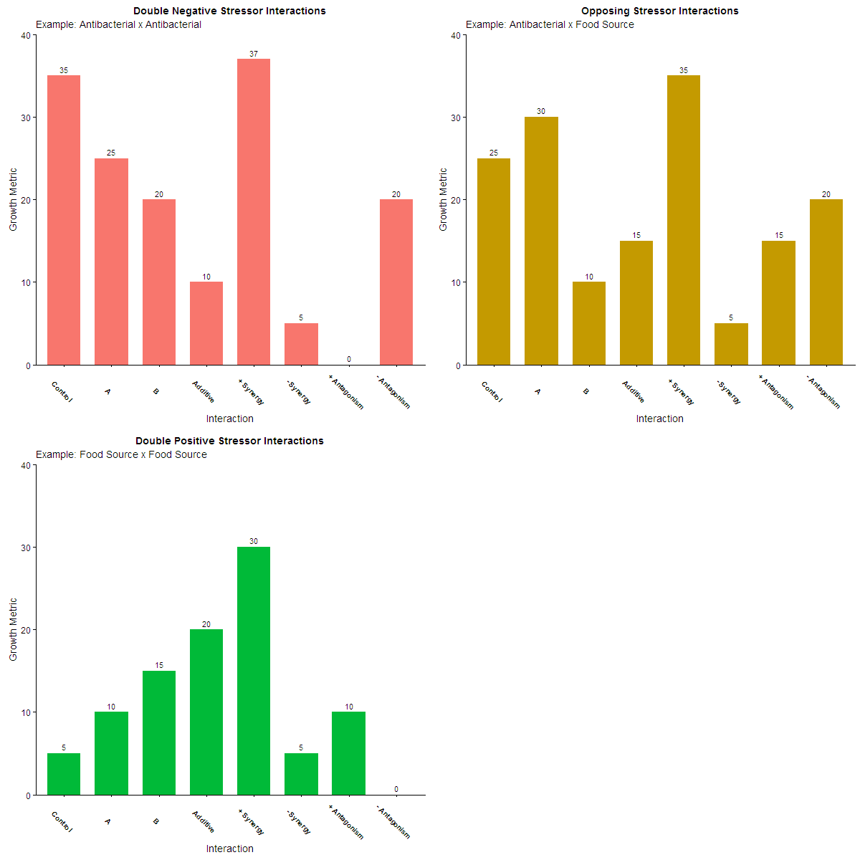

**Figure 1:** *Directionality and magnitude of double negative, opposing and double-positive stressor interactions. Adapted from a figure in Piggott, Townsend and Matthaei, 2015.*

*Effects of Stressors A and B can be determined by subtracting growth under control conditions from growth under individual treatments. As effects can be either positive or negative, care must be taken to include this directionality when calculating the effect size of interactions.*

I will polish up the aesthetics of these graphs in the fullness of time.

|  |  |  |  |  |  |
| --- | --- | --- | --- | --- | --- |
| Stressor | Functional Group | Legislative Limit | Form / Product Code | Bacterial mechanisms of action | Bacterial mechanisms of resistance |
| Chloramphenicol | Antibacterial | 0.05 μg/L  (no legal limit) | Powder, ≥98%  Sigma Aldrich C0378 | Protein synthesis, 50S | Reduced membrane permeability, mutant ribosomes, anti-AB enzymes |
| Ampicillin | Antibacterial | 0.12 μg/L  (no legal limit) | Ampicillin sodium salt  Sigma Aldrich A9518 | Cell wall synthesis | β-lactamase enzymes, efflux |
| Atrazine | Pesticide (herbicide) | 0.25 μg/L  (Tap water) | Powder, analytical  Sigma Aldrich 45330 | Oxidative stress, nitrogen source | Biodegradation |
| Metaldehyde | Pesticide (molluscicide) | 0.5 μg/L  (Tap water) | Powder, analytical  Sigma Aldrich 63990 | Toxicity unknown, possibly carbon/energy source | Biodegradation |
| Copper | Heavy Metal | 2000 μg/l  (Tap water) | Cu(II)Cl2, dihydrate (99%)  Alfa Aesar 12458 | Essential respiratory nutrient, enzymatic disruption | Efflux, chelation, rapid repair, membrane transition |
| Nickel | Heavy Metal | 20 μg/l  (Tap water) | Ni(II)Cl2, anhydrous (98%)  Alfa Aesar B22085 | Enzymatic inhibition, iron/zinc homeostasis disruption, weak oxidative stress, bacterial enzymatic nutrient | Sequestration, efflux, membrane transition |
| Tebuconazole | Antifungal | 1 μg/l  (regulatory acceptable concentration) | Powder, analytical  Sigma Aldrich 32013 | Unknown | Biodegradation |
| Azoxystrobin | Antifungal | 3 μg/l  (regulatory acceptable concentration) | Powder, analytical  Sigma Aldrich 31697 | Unknown | Biodegradation |

**Table 1**: *Summary information on selected chemical stressors.*